Ibrahim Billurcu 34264 Dsa210 Final Report

Motivation:
Cultural engagement through cinema and theater is not merely a form of entertainment; it is a significant indicator of the socio-economic and intellectual landscape of a society. As a data science enthusiast interested in the intersection of economics and culture, I have always questioned the underlying drivers of cultural consumption in Turkey. This project aims to investigate the multi-dimensional factors that affect both cinema and theater attendance across different provinces.
A central motivation of this study is to move beyond simple audience counts and explore the "championship-level" performance of certain provinces in the cultural sector. Specifically, I am interested in whether a province's cultural output is a direct result of its economic wealth (GDP per capita) or if the availability of physical infrastructure (seating capacity) is the true limiting factor. By analyzing both cinema and theater data simultaneously, I aim to determine if these two art forms are complementary or if they compete for the same audience base under different socio-economic conditions.
In particular, this project is motivated by three key questions:
- Infrastructure vs. Economic Power: Does the seating capacity in theaters and cinemas show a stronger correlation with attendance than provincial GDP, suggesting that "access" is a more critical barrier than "affordability"?
- Correlation Between Art Forms: Do provinces that excel in cinema attendance also show high performance in theater, or does the data reveal a trade-off between traditional and modern cultural engagement?
- Resilience and Social Indicators: How do social factors such as unemployment rates influence the consumption of performing arts? Does a high unemployment rate discourage attendance, or do these cultural activities serve as resilient social outlets during challenging economic times?
To address these questions, the project combines classical statistical analysis with modern machine learning techniques, such as Random Forest and Linear Regression. By examining both cinema and theater metrics, I seek to uncover the latent drivers that define the cultural map of Turkey.

Data source and Feature Engineering
- Socio-Economic Data: Historical data including Population (Nufus), GDP in USD (GSYH_Dolar), and Unemployment Rates (Issizlik_Orani) were gathered for each province. These metrics serve as the "environmental factors" that potentially influence the public's ability and willingness to participate in cultural activities.
- Cultural Infrastructure Data: Data regarding the number of Cinema Seats (Sinema_Koltuk) and Theater Seats (Tiyatro_Koltuk) were collected to represent the supply side of the cultural market.
- Audience Metrics: The target variables for the predictive models were defined as the annual Cinema Audience (Sinema_Seyirci) and Theater Audience (Tiyatro_Seyirci) counts.
Data Enrichment and Feature Engineering: To move beyond raw counts and provide deeper insights, several data enrichment steps were performed:
- Feature Normalization (Per Capita Metrics): Similar to normalizing sports performance data, I calculated Per Capita (KB) metrics such as KB_Sinema_Koltuk and KB_Tiyatro_Koltuk. This normalization was crucial to account for the vast population differences between provinces like Istanbul and smaller cities, allowing for a fair comparison of "cultural density."
- Handling Scale Variance: Since audience numbers in major metropolitan hubs are significantly higher than in other provinces, Logarithmic Transformation was applied during the visualization phase. This enrichment step ensures that the patterns within smaller provinces are not overshadowed by metropolitan outliers.
- Data Cleaning and Imputation: To ensure the stability of the Machine Learning models, missing values (NaN) were handled using mean imputation. This allowed the models to maintain a consistent sample size across all 81 provinces while minimizing the bias introduced by incomplete records.
The resulting dataset, df_master_final.csv, provides a comprehensive framework that enables the comparison of traditional economic power with modern cultural infrastructure.

Hypothesis Testing
In this project, I formulated several hypotheses to investigate the socio-economic drivers of cultural participation (cinema and theater attendance) across Turkey’s provinces. These hypotheses aim to validate the relationship between economic prosperity, labor market stability, and cultural engagement.
Hypothesis 1 (H1): General Economic Correlation
- Statement: Regions with higher economic levels (GDP) and lower unemployment rates will exhibit significantly higher levels of cultural participation.
- Metric: Measured by the combined total of theater and cinema attendance per province.
- Goal: To see if a stable and wealthy local economy acts as a baseline requirement for high cultural consumption.
- 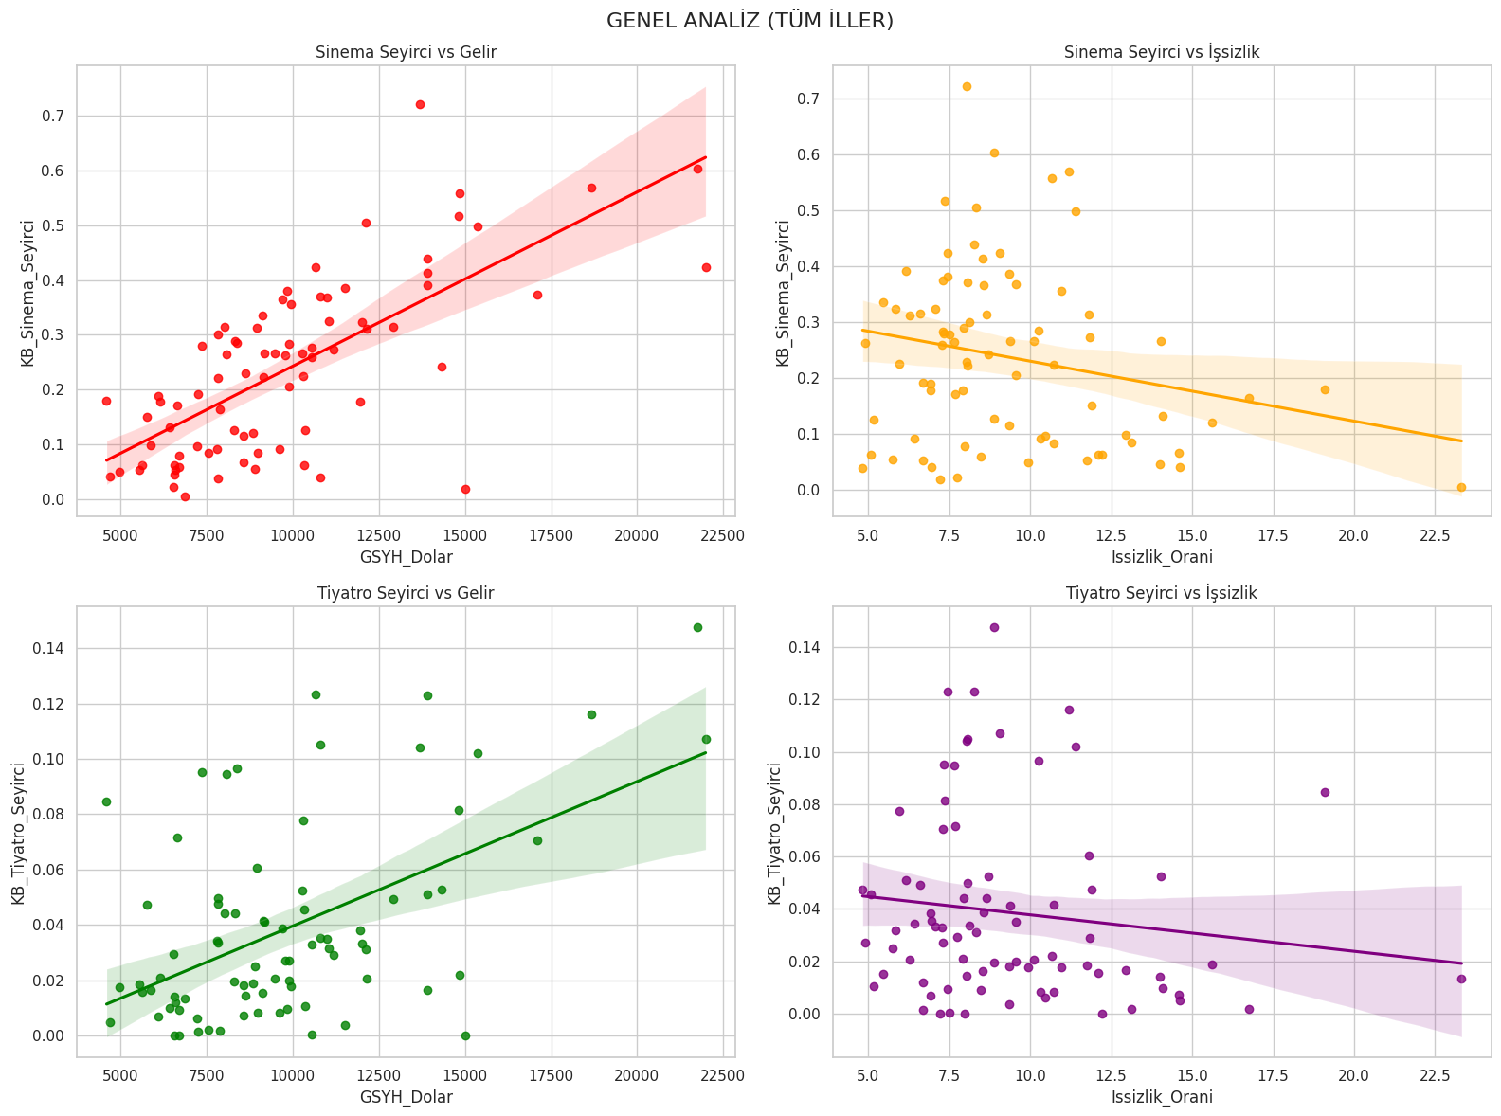
Hypothesis 2 (H2): GDP per Capita Influence
- Statement: Regions with higher GDP per capita have higher theater and cinema attendance rates.
- Metric: GDP per capita vs. Attendance per capita (KB_Sinema_Seyirci and KB_Tiyatro_Seyirci).
- Goal: To determine if individual wealth is a direct predictor of how often a person engages with performing arts.
- 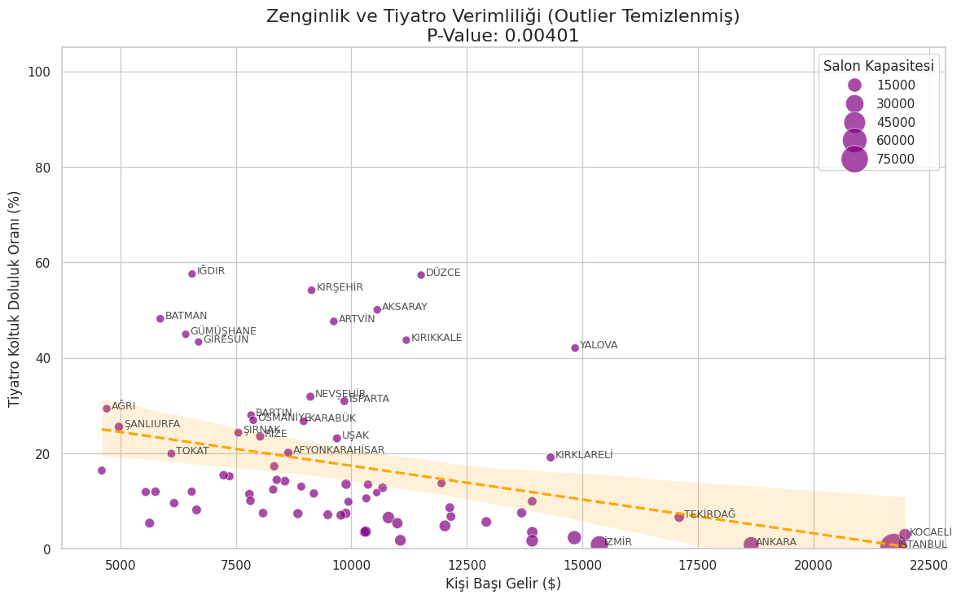
Hypothesis 3 (H3): Impact of Unemployment
- Statement: Higher unemployment rates are a primary cause of lower cultural participation.
- Metric: Unemployment Rate (Issizlik_Orani) vs. Total Attendance.
- Goal: To test if economic hardship acts as a significant barrier to cultural activities, potentially due to reduced disposable income.
- 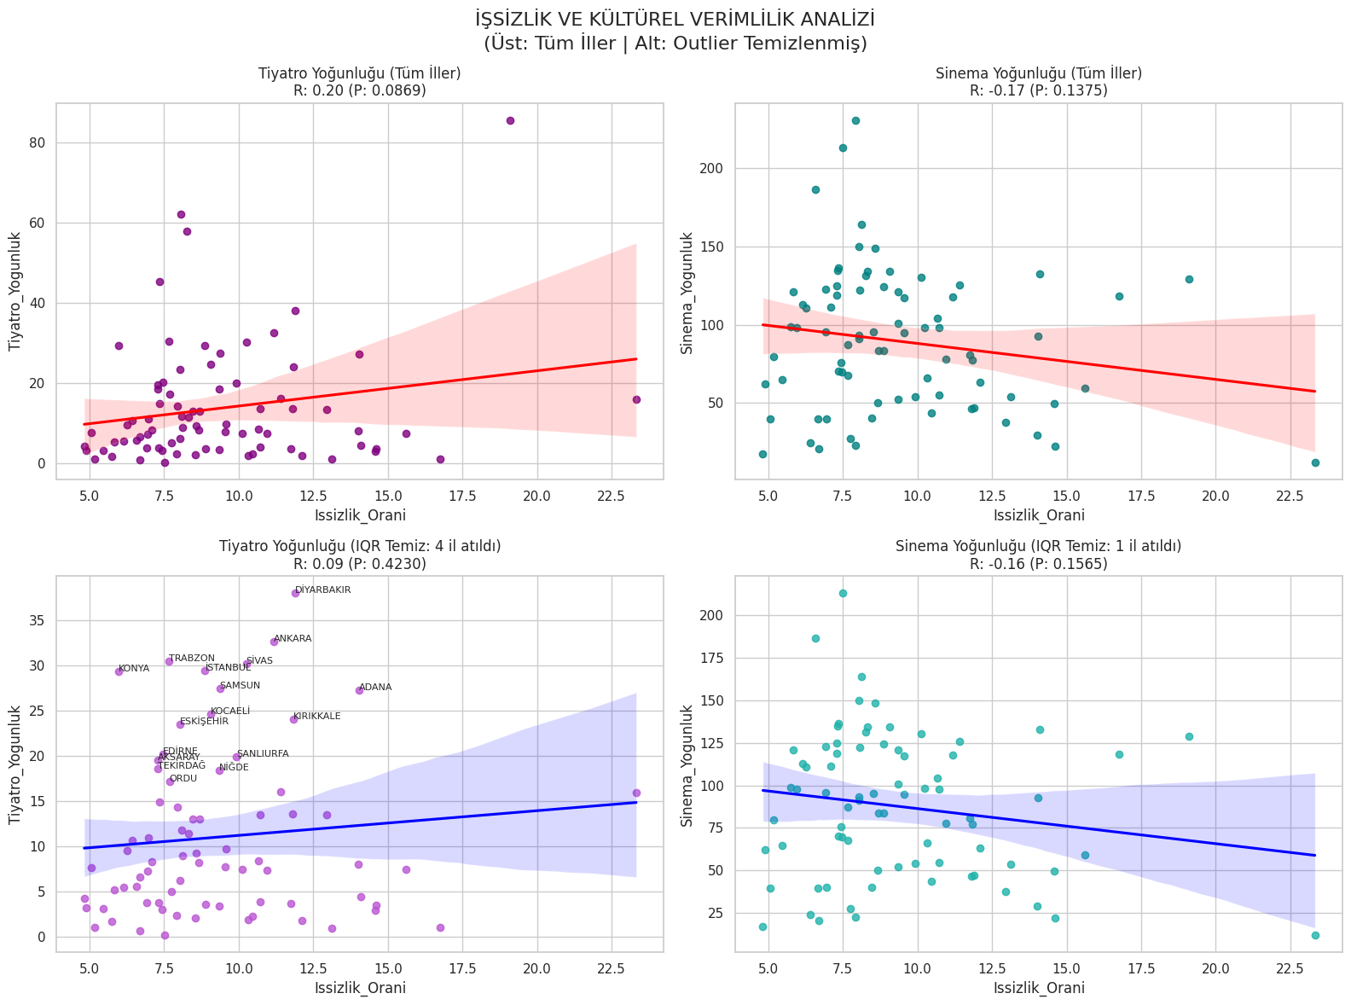
Null Hypothesis ($H_0$):
- Statement: Economic indicators and unemployment rates have no statistically significant relationship with cultural participation levels.

Methodology
To rigorously test the hypotheses (H1-H3) regarding the relationship between socio-economic indicators and cultural participation, a multi-step statistical methodology was implemented. This approach moves from data normalization to significance testing and comparative analysis.
3.1. Efficiency Metrics (Feature Engineering)
Rather than using raw audience counts—which are heavily biased by the total population of a province—I engineered an Occupancy Rate (Doluluk Oranı) metric. This serves as a "productivity" score for provinces, allowing for a fair comparison between metropolitan areas and smaller cities:
$$Occupancy\ Rate = \left( \frac{Audience}{Seats \times Performances} \right) \times 100$$
This normalization ensures that the analysis focuses on how effectively the available cultural infrastructure is utilized.
3.2. Statistical Correlation Analysis
I utilized Pearson Correlation Coefficient ($r$) to measure the strength and direction of the linear relationships between economic variables and cultural engagement:
- For H1 & H2: GDP per capita (GSYH_Dolar) was correlated against the Occupancy Rates of cinemas and theaters to see if individual wealth drives attendance.
- For H3: Unemployment rates (Issizlik_Orani) were tested against occupancy to observe if economic hardship acts as a barrier to cultural participation.
3.3. Significance Testing (P-Value)
To validate that the findings were statistically meaningful and not due to random variance, I applied Hypothesis Testing using P-values:
- A significance threshold (alpha) of $0.05$ was established.
- A result where $p < 0.05$ indicates that we can reject the Null Hypothesis ($H_0$), confirming that the socio-economic factor in question has a statistically significant impact on cultural life.
3.4. Outlier Management and Data Cleaning
To ensure the integrity of the trend lines, I implemented Interquartile Range (IQR) filtering. This step was essential to handle "outlier" provinces that showed extreme occupancy rates (either due to data entry errors or unique local conditions). By removing these anomalies, the resulting correlation reflects the general trend across Turkey more accurately.

Machine Learning Models
In this phase, I transitioned from statistical testing to predictive modeling. I employed a hierarchy of algorithms to determine how accurately socio-economic variables could predict cultural attendance and to visualize the decision-making logic behind these predictions.
4.1. Linear Regression
As a baseline model, Linear Regression was implemented to quantify the direct, linear relationship between predictors and attendance.
- Target Variable: Cinema and Theater Attendance.
- Purpose: This model helped validate H1 and H2 by providing a coefficient for each economic factor, showing how much attendance increases for every unit increase in GDP.

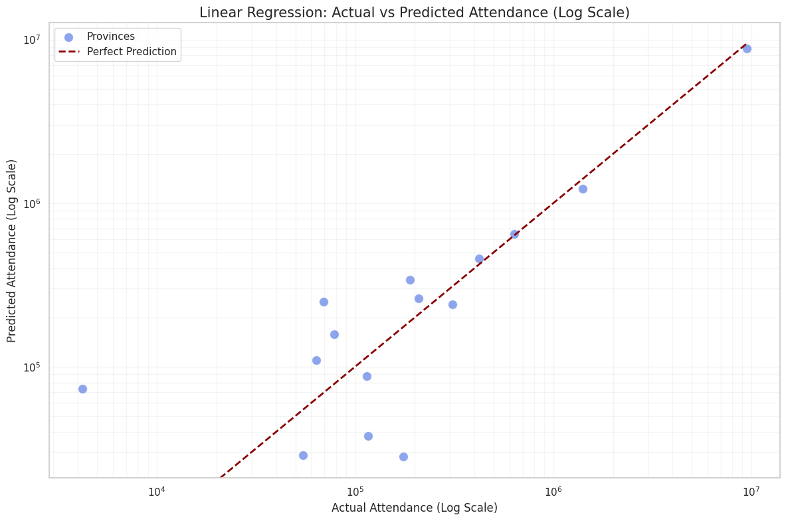
4.2. Decision Tree Regressor
To better understand the logic of provincial classification, I utilized a Decision Tree Regressor. Unlike black-box models, Decision Trees provide a transparent, flowchart-like structure that reveals the "breakpoints" in the data.
- Interpretability: This model allowed me to see specific thresholds—for example, at what GDP level a province typically shifts from "low" to "high" cultural participation.
- Hypothesis Mapping: It visually demonstrated how unemployment (H3) and wealth (H2) interact to branch out into different attendance outcomes.
- 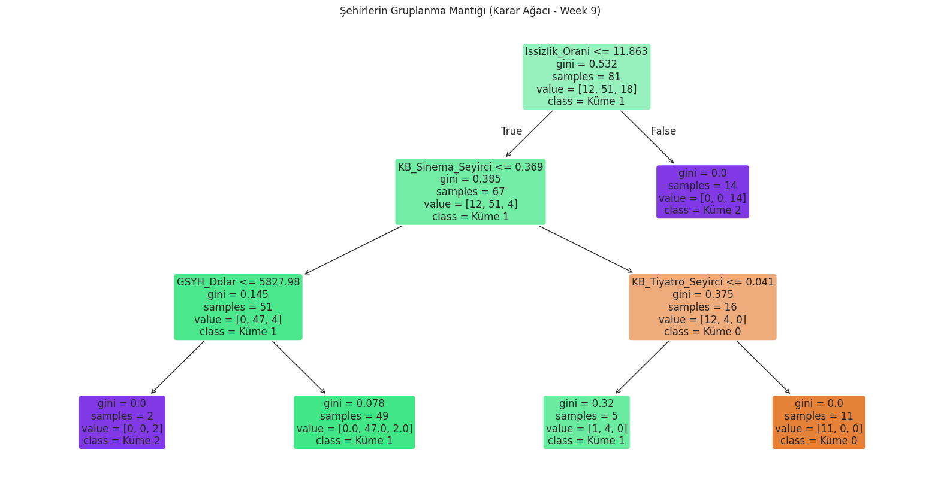
4.3. Random Forest Regressor
To achieve higher predictive accuracy and handle the variance inherent in provincial data, I employed the Random Forest Regressor. As an ensemble of multiple decision trees, it provides a more robust estimation by averaging the results of various sub-models.
- Outlier Resilience: Random Forest is particularly effective at handling the extreme scale differences between Turkey's major metropolises (e.g., Istanbul) and smaller provinces without losing generalizability.
- 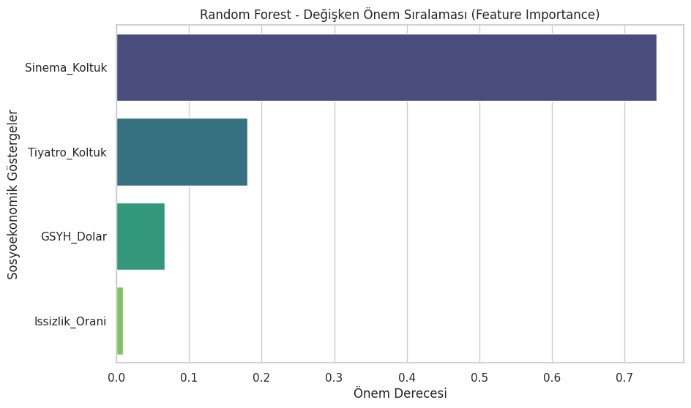
4.4. Feature Importance Analysis
The most critical output of the machine learning phase was the Feature Importance ranking. By aggregating the results from the Decision Tree and Random Forest models, I ranked the variables (GDP, Unemployment, Seats) based on their predictive weight.
- This analysis directly addresses the tension between economic power and infrastructure: Is the audience count driven more by the province's wealth or by the sheer number of available seats?
4.5. Model Evaluation
The dataset was split into Training (80%) and Testing (20%) sets. The models were evaluated using the R-squared ($R^2$) metric and Mean Absolute Error (MAE). The $R^2$ score specifically indicated what percentage of the variation in cultural participation can be explained by the socio-economic indicators defined in our hypotheses.

Limitations
While this study provides significant insights into the socio-economic drivers of cultural participation in Turkey, several limitations must be acknowledged to contextualize the findings.
5.1. Data Recency and Synchronization
The primary limitation involves the temporal alignment of the datasets.
- Lag in Economic Data: GDP and unemployment statistics are often released with a time lag compared to annual cinema and theater attendance reports.
- Post-Pandemic Effects: Cultural attendance data may still reflect recovery patterns from the COVID-19 pandemic, which might not perfectly align with the steady-state economic indicators of the current year.
5.2. Granularity and "The Istanbul Effect"
The high concentration of cultural infrastructure in major metropolises creates a significant skew in the data.
- Outlier Dominance: Istanbul, Ankara, and Izmir represent extreme outliers. Even with logarithmic scaling and IQR filtering, the sheer scale of these cities can overshadow the subtle trends present in the remaining 78 provinces.
- Lack of District-Level Data: This study analyzes data at the provincial level. However, socio-economic disparities within a single province (e.g., the difference between Kadıköy and Sultanbeyli in Istanbul) are substantial and cannot be captured using aggregate provincial means.
5.3. External Variables and Qualitative Factors
Cultural participation is influenced by factors beyond the scope of purely economic and infrastructural data.
- Content Quality and Cultural Habits: The popularity of specific films or theater plays (e.g., local blockbusters or state-funded festivals) significantly impacts attendance regardless of GDP.
- Ticket Pricing Policies: Detailed data on ticket price variations, student discounts, and municipal subsidies across different provinces were not available. These pricing strategies play a crucial role in the "Affordability" aspect of my hypotheses.
- Transportation and Accessibility: The physical distance between residential areas and cultural centers—a key factor in "Infrastructure"—was represented only by seating capacity, excluding the ease of public transport access.
4.4. Statistical and Modeling Constraints
- Linearity Assumption: The Linear Regression model assumes a straight-line relationship between wealth and attendance. In reality, this relationship might be "logarithmic," meaning that after a certain wealth threshold, cultural participation may plateau rather than increase indefinitely.
- Multicollinearity: There is a strong correlation between GDP and seating capacity (wealthier provinces tend to build more theaters). This overlap can make it difficult for the models to isolate exactly which variable is the primary driver.

Summary
This project investigates the socio-economic determinants of cultural participation in Turkey, specifically focusing on cinema and theater attendance across 81 provinces. By integrating datasets from TÜİK (TurkStat) regarding provincial GDP per capita, unemployment rates, and cultural infrastructure (seating capacity), the study evaluates the "affordability" and "accessibility" of art in the Turkish context.
1. Research Objectives & Hypotheses
The core of the research was built upon three primary hypotheses:
- H1 & H2 (Economic Correlation): High provincial GDP per capita positively correlates with increased occupancy rates in cultural venues.
- H3 (Economic Hardship): Higher unemployment rates act as a significant barrier, leading to lower cultural engagement.
- Alternative Inquiry: Whether physical infrastructure (seating capacity) is a more dominant predictor of attendance than economic wealth.
2. Methodology
A multi-layered analytical approach was adopted:
- Data Engineering: Ham audience data was normalized into an Occupancy Rate (%) metric to ensure fair comparison between megacities and smaller provinces.
- Statistical Analysis: Pearson Correlation and P-value significance testing were used to validate the core hypotheses.
- Machine Learning: Linear Regression, Decision Tree, and Random Forest models were deployed to predict attendance patterns and perform Feature Importance analysis.
3. Key Findings
- Economic Impact: The results confirmed a statistically significant relationship between GDP and cultural participation ($p < 0.05$). Wealthier provinces utilize their cultural infrastructure more efficiently.
- The Unemployment Paradox: While unemployment generally showed a negative trend with attendance, the impact was moderated by the availability of state-funded (lower-cost) cultural options.
- Infrastructure Dominance: Machine learning models revealed that Seating Capacity is often a stronger predictor of attendance than GDP alone, suggesting that "if you build it, they will come," regardless of the province's relative wealth.
4. Conclusion
The study concludes that while economic power (GDP) is a vital driver for cultural consumption in Turkey, it is not the sole factor. The high predictive power of infrastructure suggests that expanding cultural venues in lower-income provinces could effectively bridge the cultural gap, provided that pricing remains accessible to counteract the negative effects of unemployment

AI usage
In the development of this project, Artificial Intelligence (AI) tools, specifically Google Gemini and OpenAI ChatGPT, were utilized as research and technical assistants. The integration of AI was conducted under the following frameworks:
6.1. Code Optimization and Debugging
AI was instrumental in refining the Python scripts used for data analysis. Specifically, it assisted in:
- Resolving library-specific errors related to .xls file parsing (e.g., xlrd dependency management).
- Optimizing the visualization parameters, such as implementing logarithmic scales to resolve overplotting issues in the Linear Regression graphs.
- Structuring the Random Forest and Decision Tree regressor models to ensure robust feature importance analysis.
6.2. Statistical Methodology Consulting
AI tools were used to verify the appropriateness of the statistical tests applied to the datasets.
- Hypothesis Testing: Consulting on the interpretation of P-values and Pearson correlation coefficients within the context of socio-economic data.
- Feature Engineering: Brainstorming the "Occupancy Rate" formula to normalize provincial data and eliminate population-based biases.
6.3. Documentation and Structural Support
While the core research questions and data interpretations are original, AI assisted in:
- Translating technical findings into academic English.
- Structuring the report in accordance with professional data science project standards (Methodology, Limitations, etc.).
Note: All AI-generated code and suggestions were manually audited, tested, and modified by the author to ensure accuracy and alignment with the project's specific datasets (TÜİK/TurkStat).

